Spring Term Newsletter Number 2 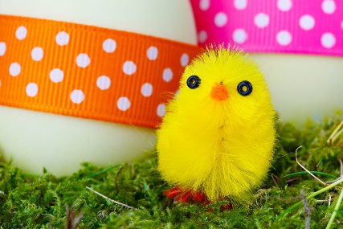
Well, we are now half way through the school year and Spring is on its way at last.
This term will be quite a busy one as we have Mother’s Day and Easter to celebrate and enjoy through arts & craft.
The committee will be holding a cake sale on Friday 22nd March @ 1pm and the Easter raffle will also be drawn in the morning with the children on this day.
This term we would like to welcome Anabelle into pre-school, she will be attending one full day a week and will be going to big school with the older children in September.
We have had a couple of cases of headlice during the last couple of terms so I would just like to take this opportunity to remind you to check your child’s hair to help prevent them spreading this to others.
We recommend using hair conditioner to comb through the hair as the eggs cannot grip onto the hair and will come off with the nit comb.
Doing this on a weekly basis will really make a difference and help prevent the headlice to spread.
Severe cases will need treatment with a stronger lotion such as Full Marks.
Children tend to play head to head in the Early Years and so to prevent the spread of headlice, WE WILL be sending children home to be treated and to return only when clear.
World book day
World book day is on the 7th March this year.
It would be great for the children to come to Pre-school dressed up as their favourite book characters.
We would like the children to bring in a book to share with the rest of the group throughout the day.
Wednesday sessions
After the Easter holidays we will be open on Wednesdays for the children who will be attending school in September.
This session will start at 9am and end at 12pm so no lunch boxes will be needed.
During this session we help to prepare the children for school, we encourage the children to sit and listen for longer periods of time and to be independent by putting coats and shoes on by themselves.
These small things will make such a huge difference to them when they start school.
A letter will be sent home within the next week or so with details about this session.

Dates for the Diary
World book day – 7th March
Cake sale & raffle – 22nd March
Break up for hols – 26th March
Return from hols – 15th April
First Wednesday session – 17th April

